5.2.2 Line Integrals Worksheet

- Let C be the curve in parameterized by for .
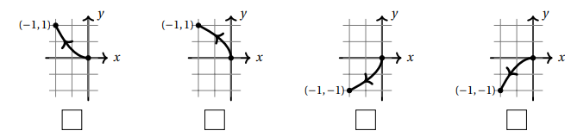
- Mark the picture of C from among the choices below.

- For the vector field compute .

- Find the work done by the force field on a particle that moves along the cosine curve from to .

We first parameterize the curve C we are moving along as where .
We then calculate

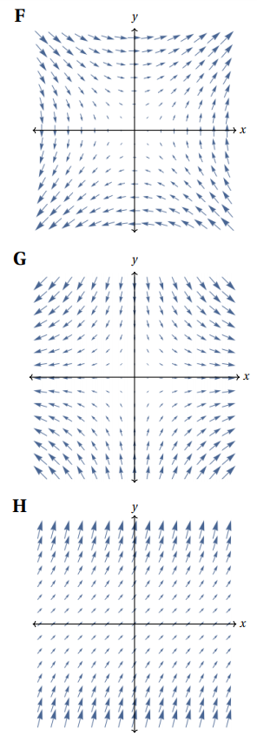
- Three continuous vector fields F,G, H on are plotted below in the region with and . Circle the best response for each of the following questions.
- Which vector field represents , where .
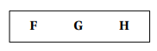
We see that which is represented by F.

- A particle moves along a straight line from to . If the vector fields represent force fields, then:

The work done by G on the particle is…
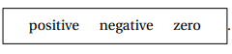
At every point on the line the direction of the vector field is orthogonal to the direction vector of the line and hence the work done is 0.

The work done by H on the particle is…


At every point on the line the direction of the vector field makes an angle of less than with the direction vector of the line. Therefore, the work done is positive.

- Find , where and C is the path along the circle of radius 3 starting at the point and ending at the point while moving clockwise.
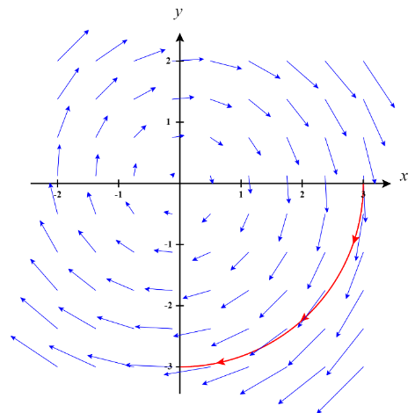
We begin by parameterizing the path C. One possible parameterization would be where .

- Consider the curve C parameterized by where .
- Check the box next to the correct sketch of C.

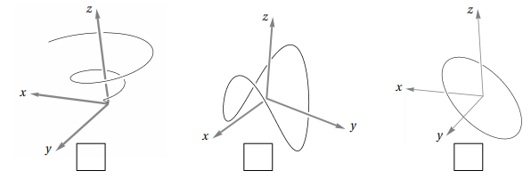

- Find the work done if a particle travels along path under the force given by the vector field .

- Let C be the helix parameterized by where .
- Let be the vector field defined by . Determine when C is oriented in the direction from to .
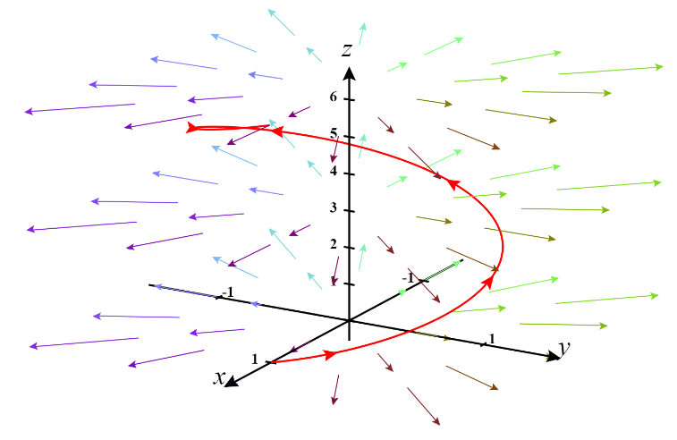

- Now let . Determine when C is given the opposite orientation.
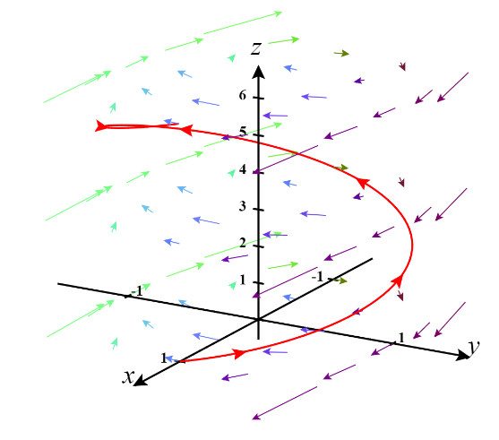

- Find the work done by the force field on a particle that moves along the parabola from to and then along the line segment from to .

We note that we are moving along a curve C which is made up of two pieces.
Let be the portion of C that is determined by the parabola. This is parameterized by where .
Let be the portion of C that is determined by the parabola. This is parameterized by where .
We then calculate
We can use Integration by Parts with to evaluate the final integral.
Note that this implies that .

Therefore,
- Evaluate the line integral where and C is the arc of the circle traversed counterclockwise from to .
- Evaluate this line integral in its current form using the formula .
We first parameterize the C as where .
We then calculate
- Rewrite the integral in the form of .
We note that .

- Evaluate the integral in the form of .
We note that

- Evaluate the line integral where and C is given by the vector function where .
- Evaluate this line integral in its current form using the formula .
We calculate

- Rewrite the integral in the form of .

We note that .

- Evaluate the integral in the form of .
We note that

- Consider the line integral where C is given by the vector function where .
- Evaluate this line integral in its current form.

- Rewrite the integral in the form of . What is F? What is ?
So we see that and .

- Evaluate the integral in the form of using the formula .

- Consider the integral where C is given by the vector function where .
- Evaluate this line integral in its current form.

- Rewrite the integral in the form of . What is F? What is ?

So we see that and .

- Evaluate the integral in the form of using the formula .

